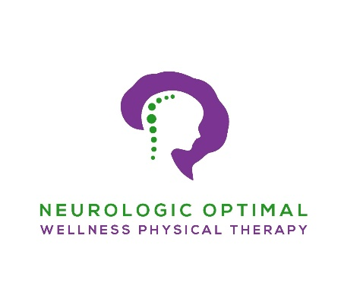
Covid-19 Protocols Policy

For: All Clients
As we continue to navigate through post pandemic the Center for Disease Control (CDC) continues to update their mask recommendations often. We want to inform you that as of 4/9/2024 masks will be optional by Neurologic Optimal Wellness. We will continue to readjust this policy as it sees fit and provide you with these updates.

If you have any questions or concerns about any protocol or policy, please feel free to contact me at neuroptnow@gmail.com or at 413-318-4776.

Katrina J. Banks, PT, DPT, CCI, CSRS, LSVT-BIG, NCS
Board Certified Neurologic Physical Therapist
413.318.4776
www.neuroptnow.com

